Thank you for joining Disability Bowls England, we are pleased to welcome you to the DBE Family.

Disability Bowls England is the home for anyone interested in Bowls, of any age, gender, ethnicity or ability. Our membership is open to anyone with a physical, sensory or intellectual disability. Our members play bowls at all levels, from Commonwealth Games , representing their country, to club friendlies to rollups.
Our Charity is run by volunteers who are here to our individual members and club members get the most out of our sport and provide information and support. We support clubs to ensure they can provide facilities for people with all types of disabilities.
What we can do for your club

- Add your club to our Club Finder section on our website
- Include a feature in our monthly Newsletter about your club
- Provide guidance on hosting ‘taster sessions’ to help you attract potential new members.
- Give support and advice to enable you to host a regular session for disabled people in your area, and to attract new members.
- Give advice on equipment and provisions to disabled players
- Arrange a match against our members
- Share your stories and events for disabled players on our website and social media pages.

Disability Bowls England knows that a Bowls Club can be a brilliant place for people to gather and play this wonderful sport; to enjoy a social scene, make new friends and take on voluntary roles.
Every club will benefit from a diverse and enthusiastic membership and DBE encourage clubs to become fully accessible, welcoming, and inclusive.
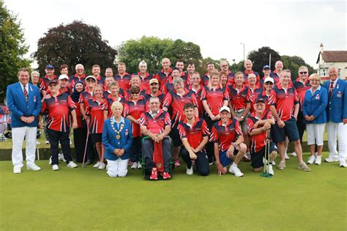

What you can do for the DBE.

- Offer to host a disability event, either a competition or friendly match
- Consider hosting a DBE ‘Taster session’ for new people with disability
- Encourage your coaches and volunteers to attend the Coach Bowls courses and modules linked with disability
- Encourage members with a disability to join DBE as a player or volunteer member and enjoy the personal benefits of meeting up and playing or helping like minded people.
- Share advice on good practice and possible funding avenues
- Provide the DBE with photos and reports or events you hold for disabled players
- Hold an annual fundraising event to help support DBE

Some disabled people have time on their hands and the skills to provide support for clubs looking for committee members or volunteers. Open your doors and opportunities for everyone.

Want to get involved?
If you would like more information about our competitions, or wish to host an event, please contact our Competition Secretary on Competions@disabilitybowlsengland.org.uk
If you are interested in playing a match against DBE Members email fixures@disabilitybowlsengland.org.uk

If you know of anyone who may be interested in joining us as either a player, volunteer or supporter contact Membership Secretary at membership@disabilitybowlsengland.org.uk
For any other information, including “Taster Sessions”, help with facilities or equipment email infor@disabilitybowlsengland.org.uk.

Our website at www.disabilitybowlsengland is the home for all sorts of information, for your club and its members. From Classifications to merchandise the website is your home for all sorts of information. We produce a newsletter which will be emailed regularly to you setting out what we have all been up to and how you can become involved.
Bowls is a game uniquely available for all people, abled bodied and otherwise to play with or against each other and as an association we want to make it possible for that to happen. Rather than Disability Bowls England we should call ourselves Diversity Bowls England, as our members come from all areas of life and are of all ages, where disability of any sort is not an impairment to joining in and playing the great game of bowls! So, WELCOME and thank you for joining our association

email: info@disabilitybowlsengland.org.uk www.disabilitybowlsengland.org.uk

Company Registration Number: 08867626
Charity Registration Number: 1162133
Registered Office: Gedling Indoor Bowls Club, Foxhill Road, Carlton, Nottingham, England NG4

